Special considerations before starting the backup:

- Verify there are more than two (2) console sessions opened from the HMC for this partition before logging into the console.
- Log in using account MISBACKUP with the password ‘backupctc’ to initiate the backup.
- Set the date and time for the backup according to the schedule (see below).

Notes about the backup:

- The weekly backup is scheduled for every Sunday morning at one (1) minute past midnight. IE 00:01AM EST on Sunday
- Duration is approximately three (3) hours to four 94) hours. Therefore, the backup should complete on Sunday at approximately between 3 – 4 AM EST.
- The backup can only be run from the console.
- If the backup fails it can be only be restarted from the beginning.
- The outage time for the weekly backup is from 00:01 AM Sunday until 10AM EST Sunday.
- Once the backup has started monitor the progress by viewing the console hourly. Examples of backup screen shots are attached at the end of this document.
- Once the backup ends the interactive session using the MIBACKUP account will create a joblog of the backup and IPL the system. Using the joblog verify the backup was successful.
- If any problems with a backup send an email to Global iSeries Support, Josee Gaudet, James Castiel, Claude Frechette. Include the issues and resolutions with dates and times.
- Do not log into the console with any other account after the weekly backup has been initiated (IE. MISBACKUP has signed in and set the backup time).

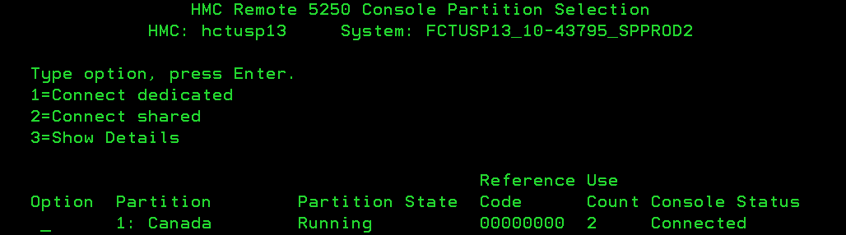

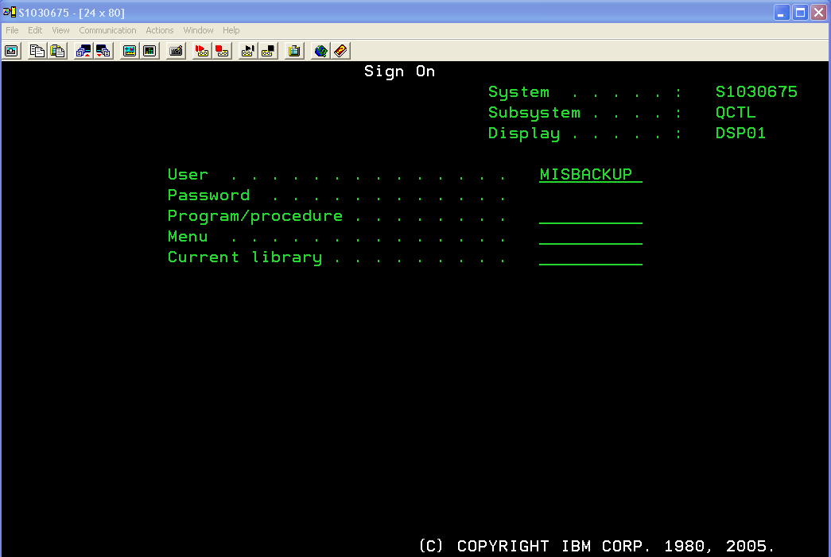

First screen shown when logging in with the MISBACKUP account

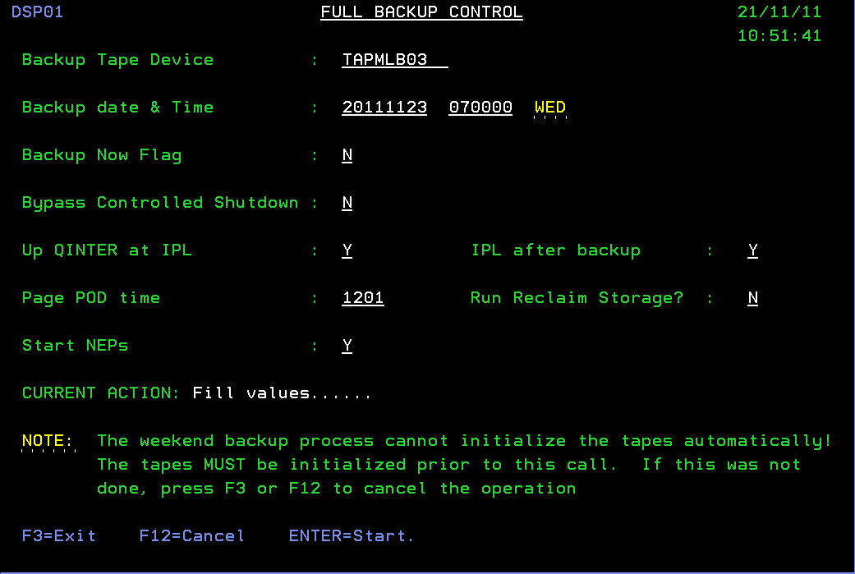
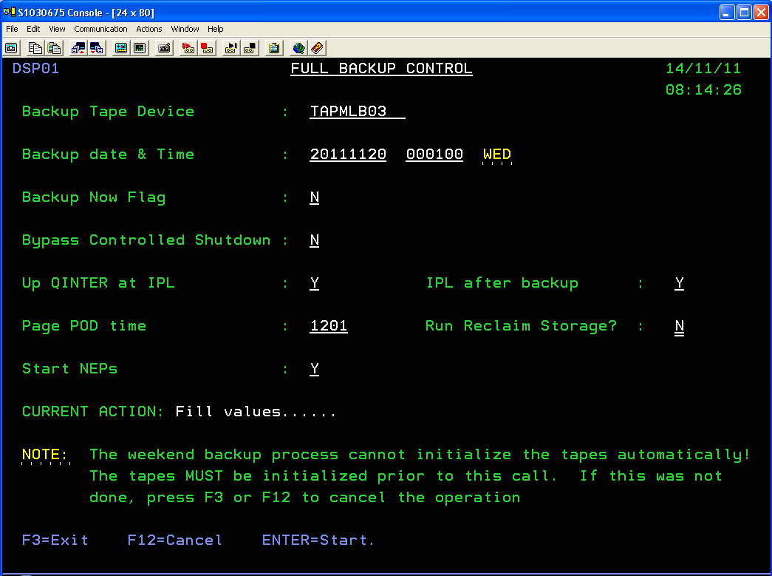

Change Backup date & Time to start on the next Sunday at 00:01 (one minute after midnight) and press Enter to validate the date.

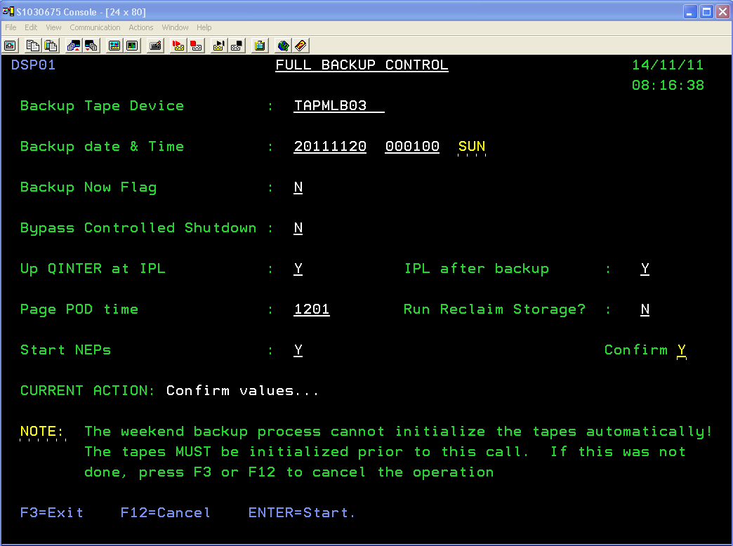

This the confirmation screen. Check the values and then press Enter. Do not change any other values unless specifically requested.

Note – the following values are the default values unless specifically asked to be changed.

Backup Now Flag N
Bypass Controller Shutdown N
Up QINTER at IPL Y
IPL after backup Y
Page POD time 1201
Run Reclaim Storage N
Start NEPs Y

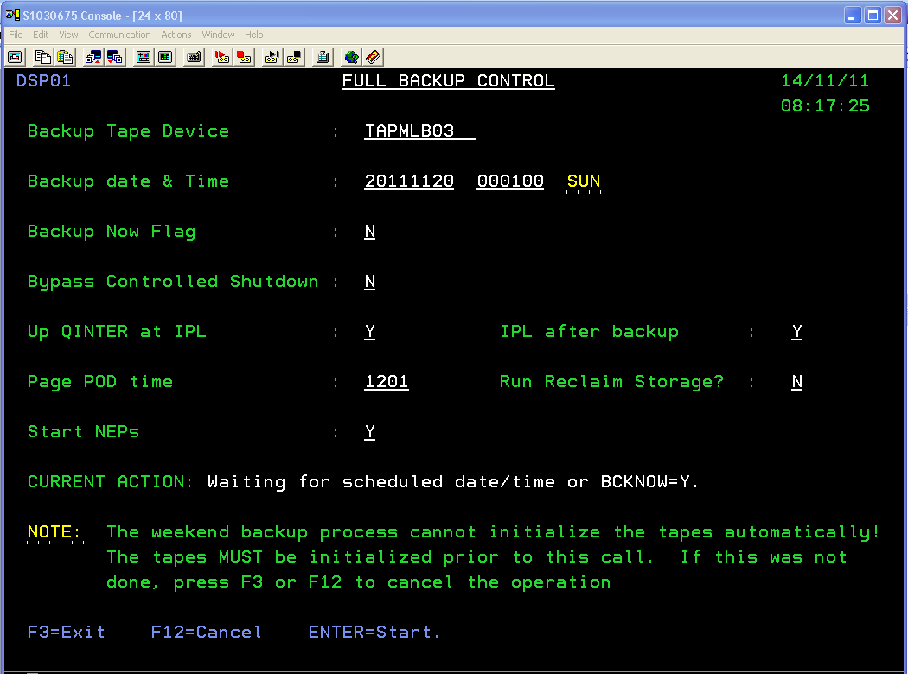

The screen will show the interactive console jobs waiting for the scheduled date/time.
If you need to cancel this screen then use the system request option or cancel the console from another interactive session.

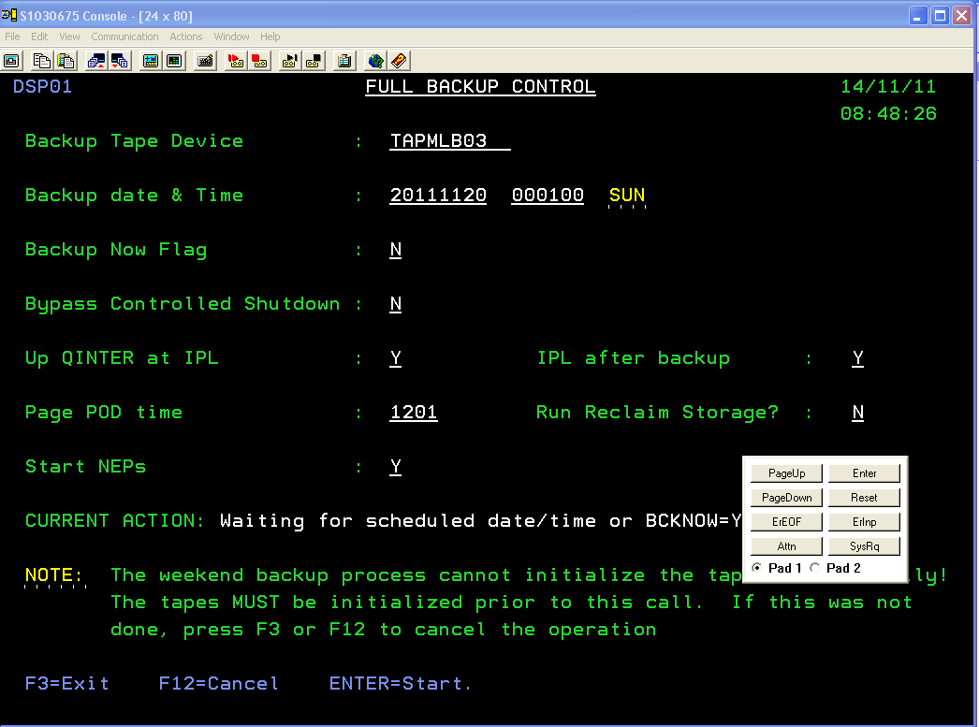

If you need to cancel this use the ‘SysReq’ and log off the session. You can always restart this screen before the scheduled backup date/time.

This session is a looping job from the console and checks the time every minute until the backup starts.

Suggestion:

Log in with MISBACKUP and start the weekly backup session on Saturday between 21:00 and 23:50 EST.

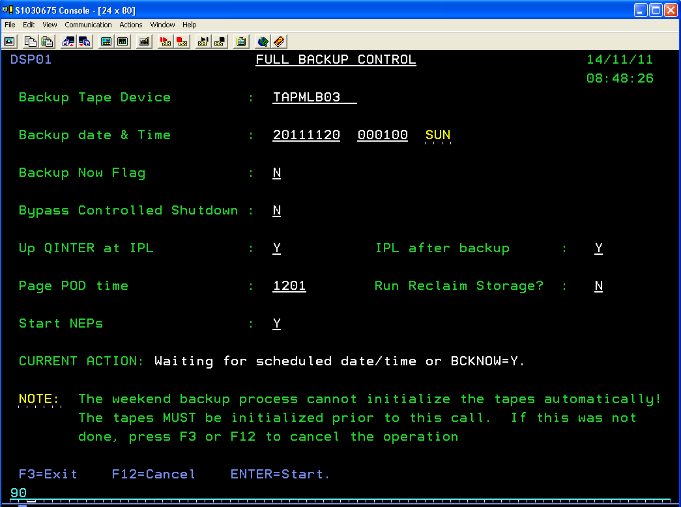

Enter ’90’ on the system request line and press enter.

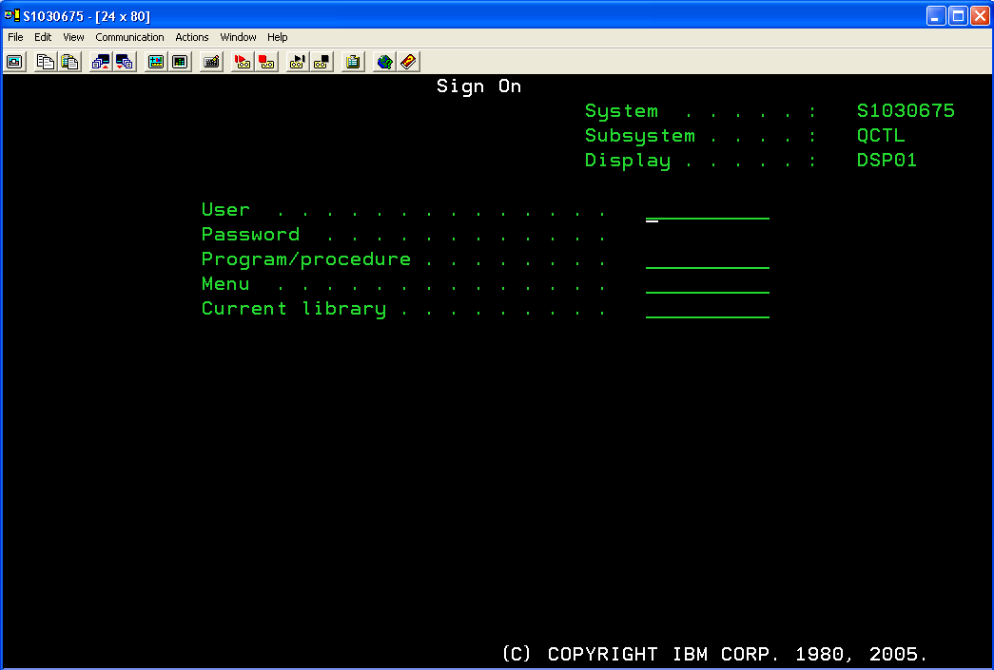

Progress examples:

